**Data Quality Report**

Ji Jie

**Description of Data:**

This dataset is about the real estate assessment property data. It is from the government of New York City, Department of finance. This dataset covers the time period of November in 2011, and it has 32 columns and 1,070,994 rows.

**Summary Tables:**

Categorical Fields Summary Table:

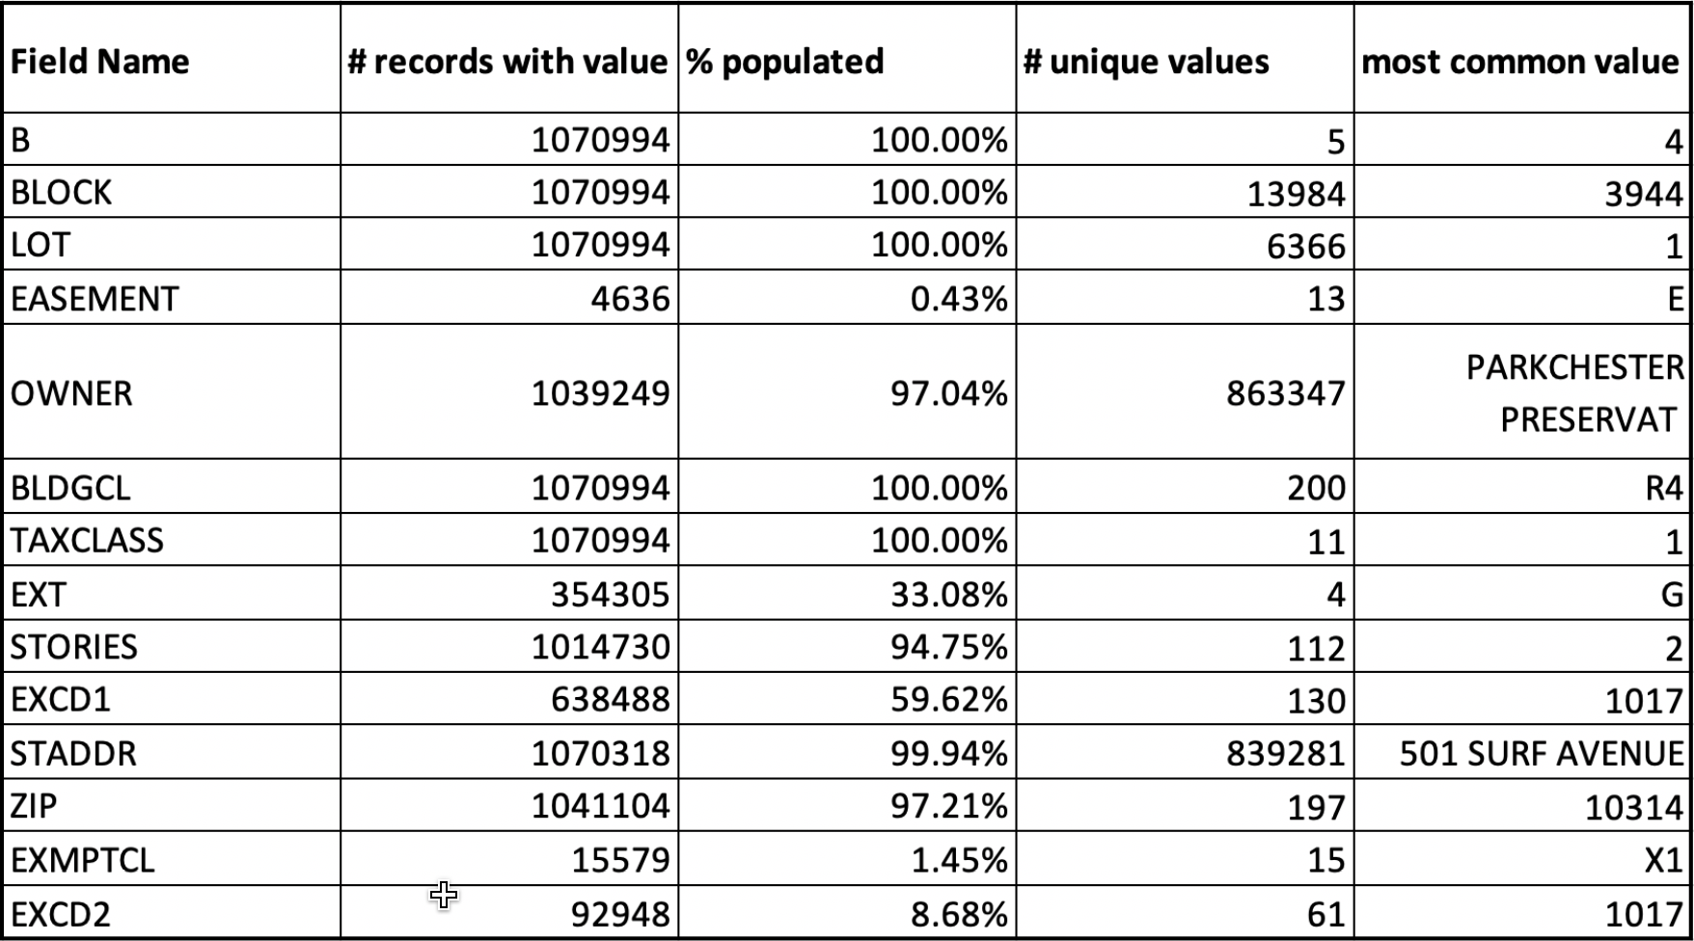

Numeric Fields Summary Table:

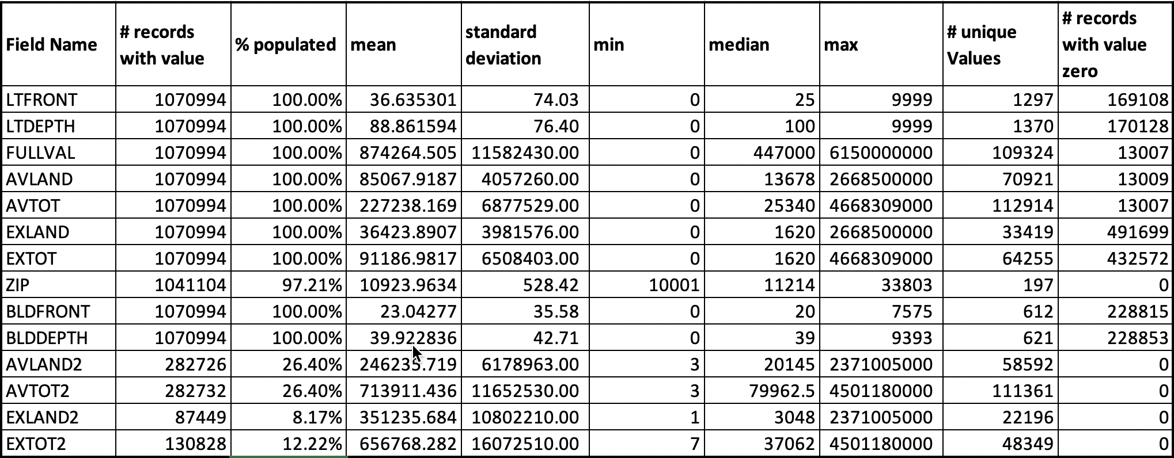

**Fields Description:**

Field1: RECORD

Description: RECORD is the unique identity code for each record.

Field2: BBLE

Description: BBLE is the concatenation of BORO, BLOCK and LOT.

Field3: B

Description: B is the borough code of each property.

Field4: BLOCK

Description: BLOCK is the block number of each property.

Field5: LOT

Description: LOT is the property’s lot number.

Field6: EASEMENT

Description: EASEMENT is a legal right to use another's land for a specific limited purpose. Different values indicate different extent of easement.

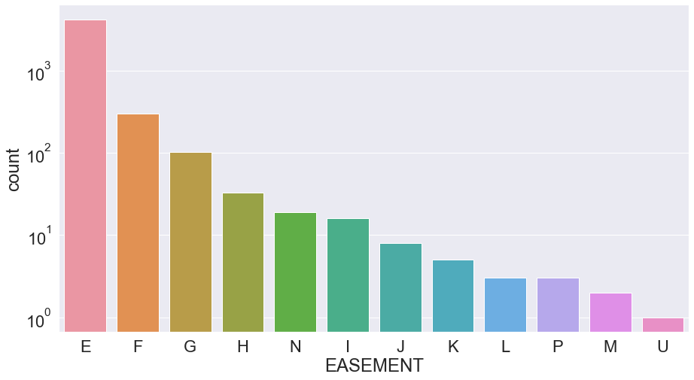

Field7: OWNER

Description: OWNER is owner’s name of the property.

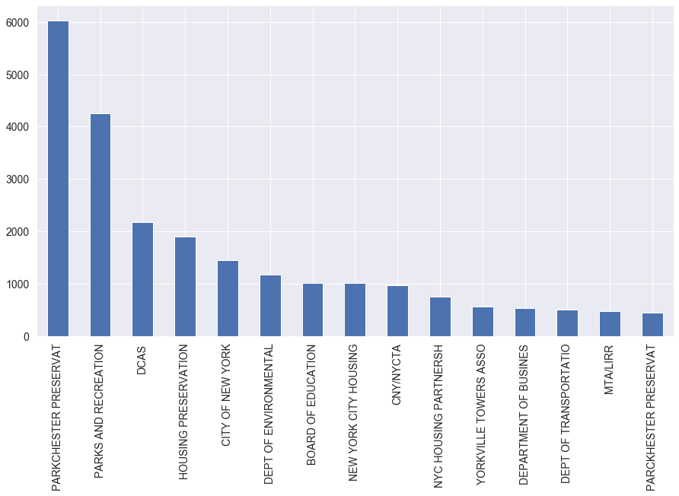

Field8: BLDGCL

Description: BLDGCL is the building class of the property.

Field9: TAXCLASS

Description: TAXCLASS is the current tax class of the property.

Field10: LTFRONT

Description: LTFRONT is the lot frontage in feet. Range from 0 to 200; 98.47% of the total records are covered.

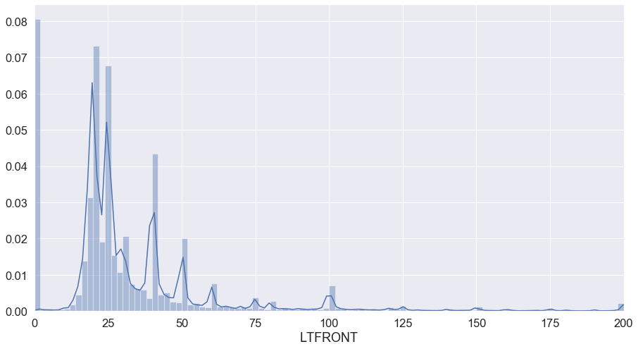

Field11: LTDEPTH

Description: LTDEPTH is the lot depth in feet. Range from 0 to 200; 98.25% of the total records are covered.

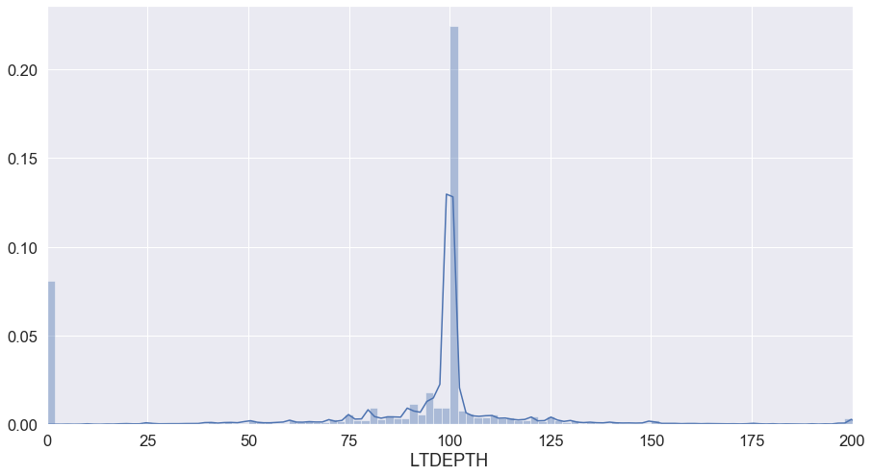

Field12: EXT

Description: EXT is the extension of the property.

Field13: STORIES

Description: STORIES is the number of stories in the building.

Field14: FULLVAL

Description: FULLVAL is the current market value of the property. Range from 0 to 1,500,000; 94.90% of the total records are covered.

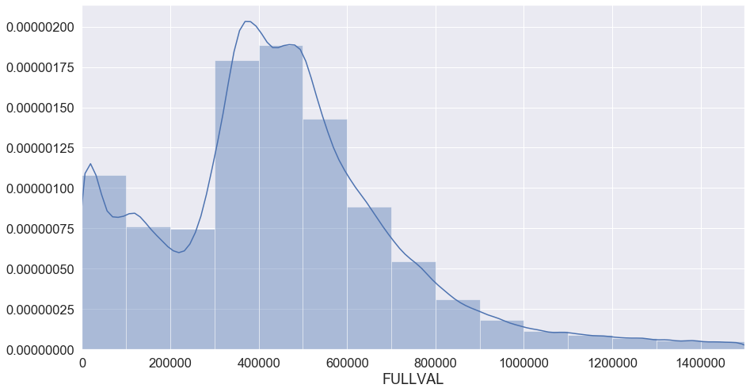

Field15: AVLAND

Description: AVLAND is the total land area. Range from 0 to 50,000; 90.52% of the total records are covered.

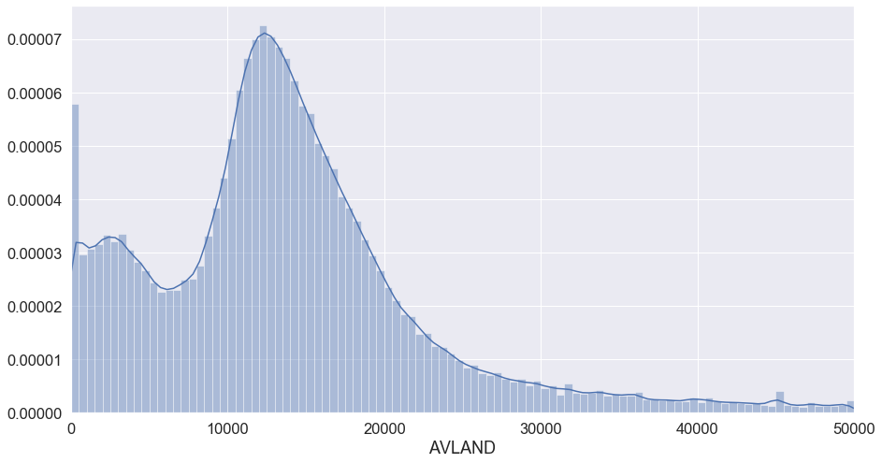

Field16: AVTOT

Description: AVTOT is the total value of the building. Range from 0 to 100,000; 86.05% of the total records are covered.

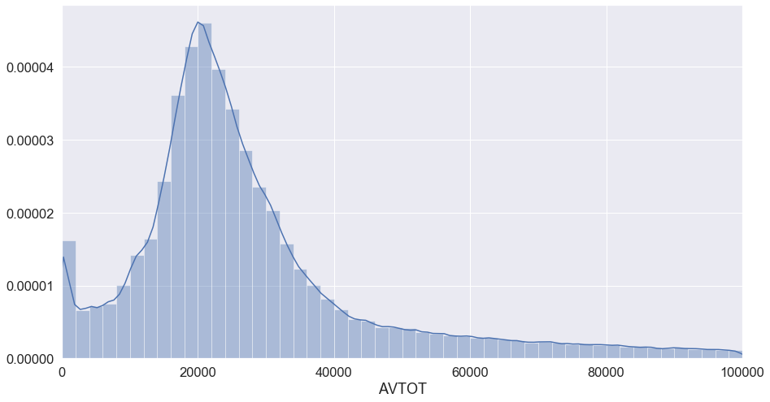

Field17: EXLAND

Description: EXLAND is the exempt value of the building. Range from 0 to 20,000; 96.82% of the total records are covered.

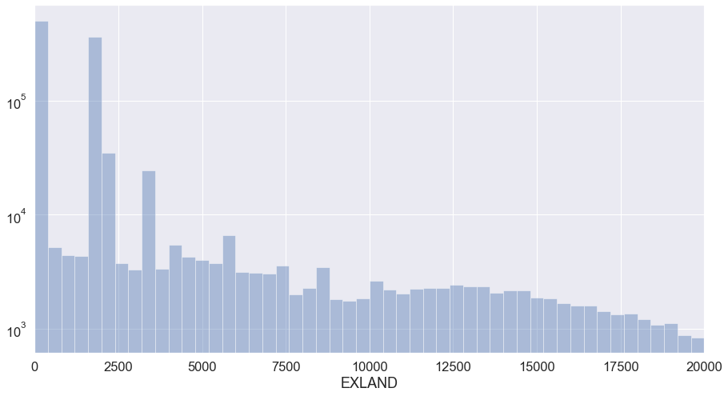

Field18: EXTOT

Description: EXTOT is the exempt land area of the building. Range from 0 to 20,000; 90.40% of the total records are covered.

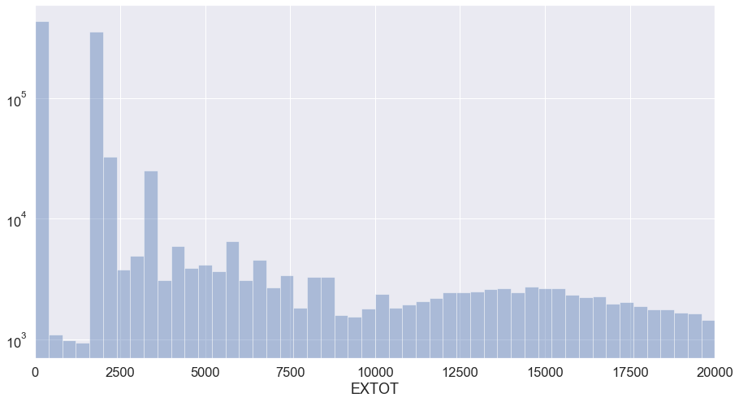

Field19: EXCD1

Description: EXCD1 is the exemption of the building.

Field20: STADDR

Description: STADDR is the street address of the property.

|  |  |
| --- | --- |
| STADDR | Count |
| 501 SURF AVENUE | 902 |
| 330 EAST 38 STREET | 817 |
| 322 WEST 57 STREET | 720 |
| 155 WEST 68 STREET | 671 |
| 20 WEST 64 STREET | 657 |
| 1 IRVING PLACE | 650 |
| 220 RIVERSIDE BOULEVARD | 628 |
| 360 FURMAN STREET | 599 |
| 200 EAST 66 STREET | 585 |
| 30 WEST 63 STREET | 562 |
| 350 WEST 42 STREET | 556 |
| 2 BAY CLUB DRIVE | 556 |
| 200 RECTOR PLACE | 549 |
| 301 EAST 79 STREET | 538 |
| 350 WEST 50 STREET | 498 |

Field21: ZIP

Description: ZIP is the zip code area of the property.

|  |  |
| --- | --- |
| ZIP | Count |
| 10314 | 24606 |
| 11234 | 20001 |
| 10312 | 18127 |
| 10462 | 16905 |
| 10306 | 16578 |
| 11236 | 15678 |
| 11385 | 14921 |
| 11229 | 12793 |
| 11211 | 12710 |
| 11207 | 12293 |
| 11215 | 11834 |
| 11235 | 11312 |
| 11203 | 11241 |
| 11208 | 11139 |
| 11204 | 11061 |

Field22: EXMPTCL

Description: EXMPTCL is the exempt class used for fully exempt properties.

Field23: BLDFRONT

Description: BLDFRONT is the building frontage in feet. Range from 0 to 20,000; 99.56% of the total records are covered.

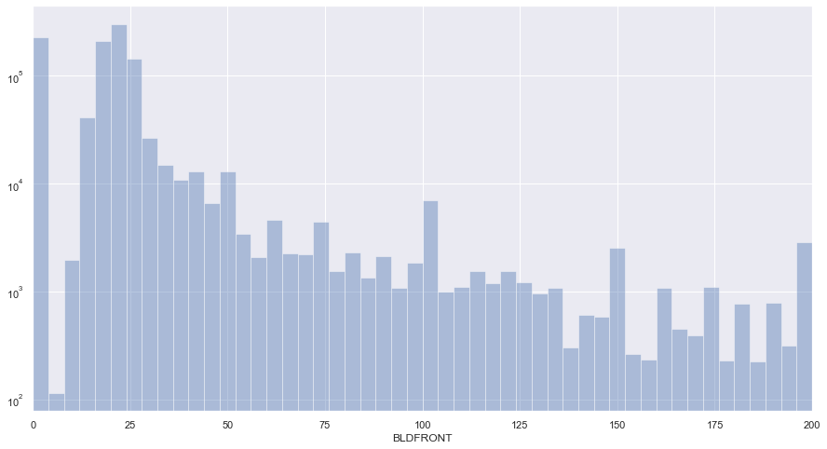

Field24: BLDDEPTH

Description: BLDDEPTH is the building depth in feet. Range from 0 to 30,000; 99.82% of the total records are covered.

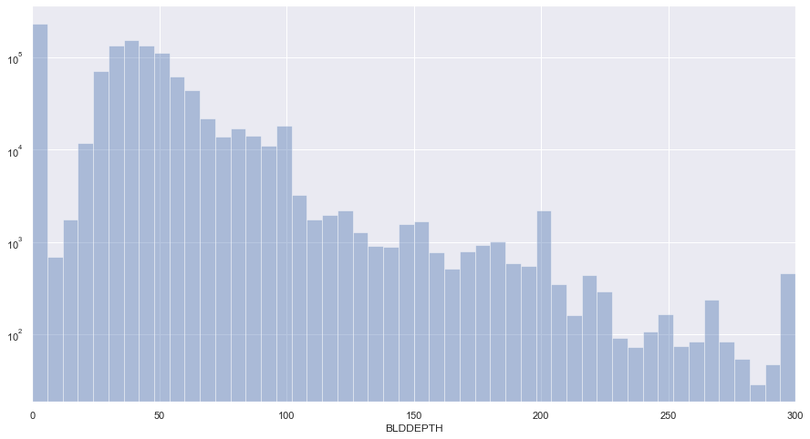

Field25: AVLAND2

Description: AVLAND2 is the transitional land value. Range from 0 to 30,000; 24.15% (26.40% populated) of the total records are covered.

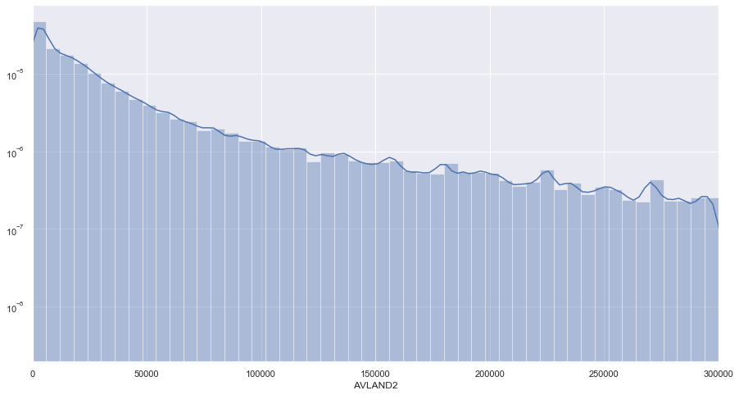

Field26: AVTOT2

Description: AVTOT2 is the transitional total value. Range from 0 to 100,000; 24.18% (26.40% populated) of the total records are covered.

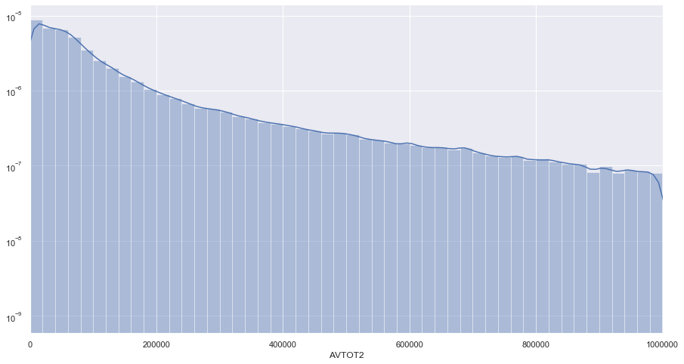

Field27: EXLAND2

Description: EXLAND2 is the transitional exempt value of the building. Range from 0 to 50,000; 6.42% (8.17% populated) of the total records are covered.

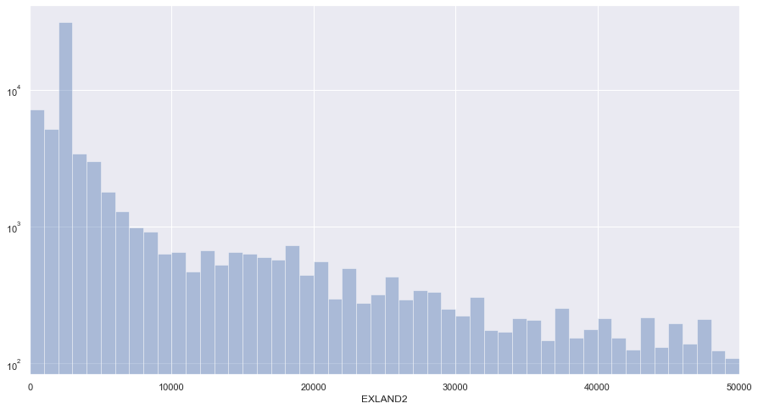

Field28: EXTOT2

Description: EXTOT2 is the transitional exempt total land area of the building. Range from 0 to 100,000; 9.03% (12.22% populated) of the total records are covered.

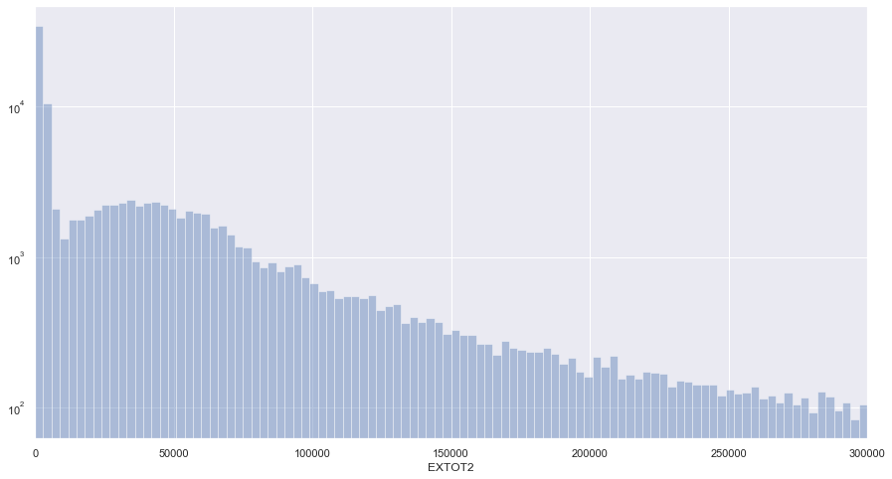

Field29: EXCD2

Description: EXCD2 is the exemption of the building.

Field30: PERIOD

Description: PERIOD is the assessment period when the record was collected.

Field31: YEAR

Description: YEAR is the assessment period year.

Field32: VALTYPE

Description: VALTYPE is the value type of the property.